USE CASE STUDY REPORT

Group No.: Group 6

Student Names: Weijie Guan, Yining Wang

Executive Summary: This case study aims to design a database to help a cinema run more efficient and accurate. As a cinema system, it must meet the basic requirements of selling and checking tickets and checking film information. In order to make it more full-featured, we also designed the snack selling function, storage checking function and vip account editing function. During the exploration of this topic, we use EER and UML models to help us better understand the structure. With further study on this case, we finally work out a system which can meet all the requirements that is necessary for a cinema system. Then we implemented the relational model we designed in mysql database and mongodb database and wrote some queries to manipulate the databases. What’s more, we also set up a connection to the mysql database in R, retrieved information about snack from the database and made a interesting plot about the sale condition of snacks.

I. Introduction
With the development of 3D technology, the experience of watching films in the cinema becomes increasingly better than that at home. People tend to go out for entertainment nowadays. As the number of customers grows, traditional management may require more human resources and financial resources. A management method with higher efficiency and confidentiality will help the cinema to better improve its operation.

The goal of our study is to design a ticketing database which can help a cinema improve its management efficiency.

In order to attract more customers, we suppose that if a customers apply for a VIP card, he can top up and each bill he pay will earn him 10% of the bill as the credits. A customer can use the credits to consume in the cinema.

The ticketing database for a cinema should meet the following basic requirements:
- VIP management: VIP card information can be checked, added, deleted and edited, including card_numberber, first name, last name, phone number, address, balance and credits.
- Film system: the information of a film can be checked including film code, name of the film, director, leading role, nationality, release year, playing date, playing time, room number.
- Staff management: each staff of the cinema has his own identity information, including id, first name, last name, age and address.
- Ticket selling: each ticket corresponds a serious of information when it was sold, including ticket number, price, film code, date, time, room number, seat number and order id.
- Ticket checking: each ticket has its own verification code for ticket checking.
- Snack selling: each snack has its id, type(name), price per unit and inventory.
- Order management: each order is recorded with an order id, total price, date and time. Orders are divided into ticket order and snack order, each has its own goods or ticket id and selling amount.
- Credit management: each order will be recorded together with order id, order type, vip id and staff id, so that the credits can be added into the account of a vip member.

II. Conceptual Data Modeling
Constraints:
When order is deleted, the relative order_info and ticket_order or snack_order should be deleted
When room is deleted, the relative play_on should be deleted
When film is deleted, the relative play_on should be deleted

Domains:
type enum('S', 'M', 'L')
occupied enum('0', '1')
order_type enum('ticket','snack')
EER model:
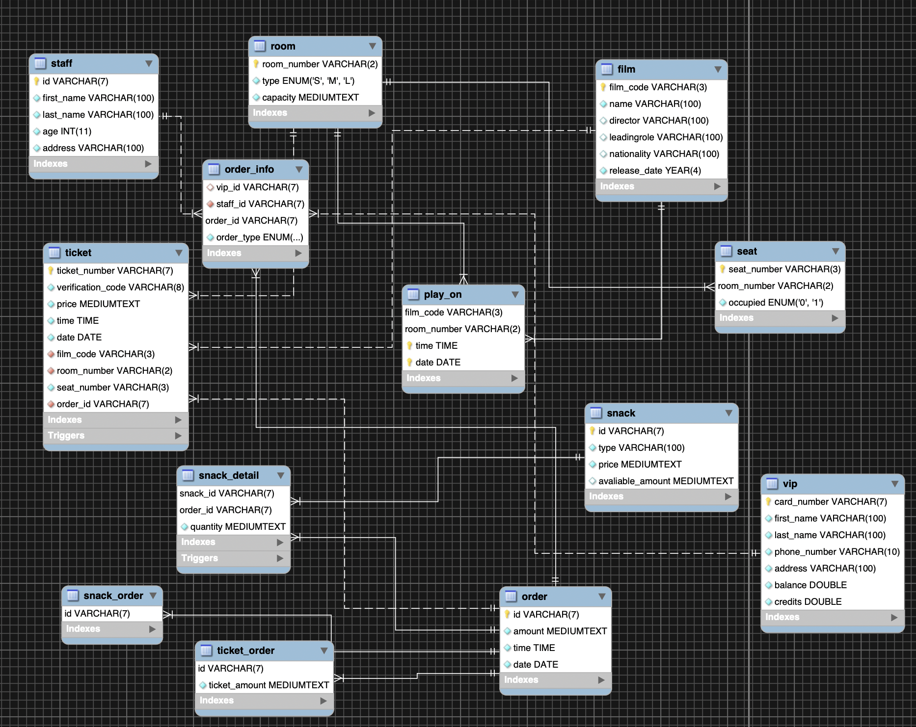

Cadinalities:

A staff can have one or many order_info.
An order_info can have one and only one staff, one and only one order, one and only one vip.
A room can have one or many tickets, one or more play_on(film playing information), and one or more seats.
A film can have one or more tickets, one or more play_on(film playing information).
A ticket can have one and only one room, one and only one film, one and only one order.
A play_on can have one and only one room, and one and only one film.
A seat can have one and only one room.
A snack_detail can have one and only one snack, and one and only one order.
A snack can have one or more snack details.
A snack_order can have one and only one order.
A ticket_order can have one and only one order.
An order can have one or many snack_order, one or many ticket_order, one or many snack_detail, one or many tickets, and one or many order_info.
A vip can have one or many order_info.

UML model:
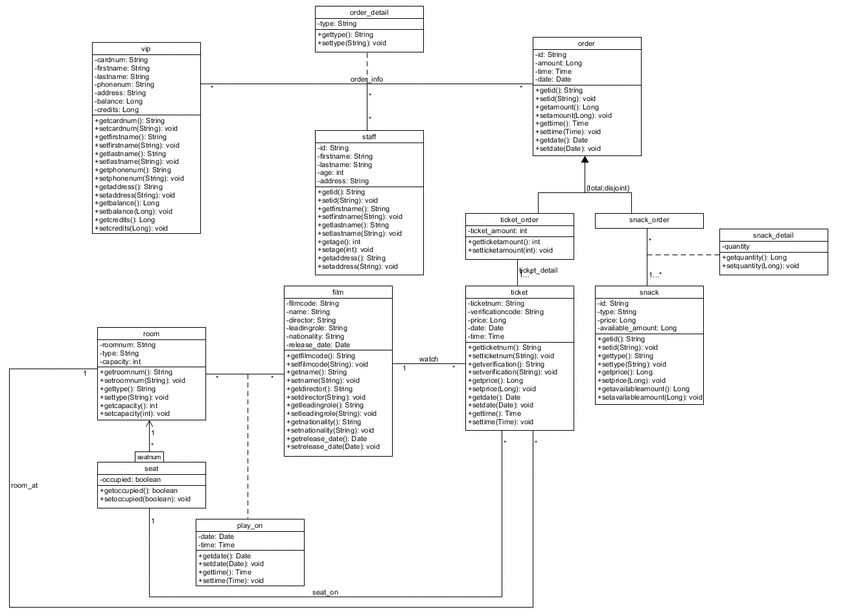

III. Mapping Conceptual Model to Relational Model
Describe mapping of the EER and UML to a relation model, including tables, primary keys, foreign keys, relational constraints

In this database, we have 13 tables, which are vip, room, seat, film, play_on, staff, ticket, snack, order, snack_order, snack_detail, ticket_order and order_info. The relational model including tables, primary keys, foreign keys, relational constraints and normalization is as following:

Vip(card_number, first_name, last_name, phone_number, address, balance, credits)
Room(room_number, type, capacity)
Seat(seat_number, occupied, room_number)
-room_number: foreign key refers to room_number in Room, NULL value not allowed
Film(film_code, name, director, leading_role, nationality, release_date)
Ticket(ticket_number, verificationcode, price, date, time, film_code, room_number, seat_number, order_id)
-film_code: foreign key refers to film_code in Film, NULL value not allowed
-room_number: foreign key refers to room_number in Room, NULL value not allowed
-seat_number: foreign key refers to seat_number in Seat, NULL value not allowed
-order_id: foreign key refers to id in Ticket_order, NULL value not allowed
Snack(id, type, price, available)
Order(id, amount, time, date)
Snack_order(id)
Ticket_order(id, ticket_amount)
Play_on(film_code, room_number, date, time)
-film_code: foreign key refers to film_code in Film, NULL value not allowed
-room_number: foreign key refers to room_number in Room, NULL value not allowed
Staff(id, first_name, last_name, age, address)
Order_info(vip_id, staff_id, order_id, type)
-vip_id: foreign key refers to card_number in Vip, NULL value allowed
-staff_id: foreign key refers to id in Staff, NULL value not allowed
-order_id: foreign key refers to id in Order, NULL value not allowed
Snack_detail(snack_id, order_id, quantity)
-snack_id: foreign key refers to id in Snack, NULL value not allowed
-order_id: foreign key refers to id in Snack_order, NULL value not allowed

IV. Implementation of Relation Model via MySQL and NoSQL
Implementation of the relational model in MySQL including populating the database. SQL demonstration is expected in presentation/demonstration.

use Final;
show tables;

create table if not exists vip (
card_number varchar(7) not null primary key,
first_name varchar(100) not null,
last_name varchar(100) not null,
phone_number varchar(10) not null,
address varchar(100) not null,
balance double not null,
credits double not null
);

create table if not exists room (
room_number varchar(2) not null primary key,
`type` enum('S', 'M', 'L') not null default 'S',
capacity long not null
);

create table if not exists seat (
seat_number varchar(3) not null,
room_number varchar(2) not null,
occupied enum('0', '1') not null default '0',
primary key (seat_number, room_number),
constraint foreign key seat(room_number) references room(room_number) on delete cascade
);

create table if not exists film (
film_code varchar(3) not null primary key,
`name` varchar(100) not null,
director varchar(100),
leadingrole varchar(100),
nationality varchar(100),
release_date year not null
);

create table if not exists play_on (
film_code varchar(3) not null,
room_number varchar(2) not null,
`time` time not null,
`date` date not null,
constraint foreign key play_on(film_code) references film(film_code) on delete cascade,
constraint foreign key play_on(room_number) references room(room_number) on delete cascade,
primary key (film_code, room_number, `time`, `date`)
);

create table if not exists staff (
id varchar(7) not null primary key,
first_name varchar(100) not null,
last_name varchar(100) not null,
age int not null,
address varchar(100) not null
);

create table if not exists ticket (
ticket_number varchar(7) not null primary key,
verification_code varchar(8) not null,
price long not null,
`time` time not null,
`date` date not null,
film_code varchar(3) not null,
room_number varchar(2) not null,
seat_number varchar(3) not null,
order_id varchar(7) not null,
constraint foreign key (film_code) references film(film_code),
constraint foreign key (room_number) references room(room_number),
constraint foreign key (order_id) references `order`(id)
);

create table if not exists snack (
id varchar(7) not null primary key,
`type` varchar(100) not null,
price long not null,
avaliable_amount long
);

create table if not exists `order` (
id varchar(7) not null primary key,
amount long not null,
`time` time not null,
`date` date not null
);

create table if not exists snack_order (
id varchar(7) not null primary key,
constraint foreign key snack_order(id) references `order`(id) on delete cascade
);

create table if not exists snack_detail (
snack_id varchar(7) not null,
order_id varchar(7) not null,
quantity long not null,
primary key (snack_id, order_id),
constraint foreign key snack_detail(order_id) references `order`(id) on delete cascade,
constraint foreign key snack_detail(snack_id) references snack(id)
);

create table if not exists ticket_order (
id varchar(7) not null primary key,
ticket_amount long not null,
constraint foreign key ticket_order(id) references `order`(id) on delete cascade
);

create table if not exists order_info (
vip_id varchar(7),
staff_id varchar(7) not null,
order_id varchar(7) not null primary key,
order_type enum('ticket','snack') not null default 'ticket',
constraint foreign key (vip_id) references vip(card_number),
constraint foreign key (staff_id) references staff(id),
constraint foreign key (order_id) references `order`(id) on delete cascade
);

create trigger snack_amount
after insert on snack_detail
for each row
update snack
set avaliable_amount = avaliable_amount - new.quantity
where id = new.snack_id;

create trigger snack_amount_update
after delete on snack_detail
for each row
update snack
set avaliable_amount = avaliable_amount + old.quantity
where id = old.snack_id;

create trigger seat_status_update
after insert on ticket
for each row
update seat
set occupied = 1
where seat_number = new.seat_number and room_number = new.room_number;

create trigger seat_status_delete
before delete on ticket
for each row
update seat
set occupied = 0
where seat_number = old.seat_number and room_number = old.room_number;

Implementation of the relational model in NoSQL: this can be a partial implementation within the online playground (e.g., a couple of tables)

db.createCollection('order')
db.createCollection('snack')
db.getCollectionNames()
db.order.insert(
[{
'id' : '3000029',
'amount' : 22.62,
'date' : '2019-11-18',
'time' : '20:29:00'
}, {
'id' : '3000028',
'amount' : 51.49,
'date' : '2019-11-20',
'time' : '13:25:00'
}]
)
db.order.find().pretty()

db.snack.insert(
[{
'id' : '2000000',
'type' : 'chocolate brownies',
'price' : 2.55,
'avaliable' : 29
}, {
'id' : '2000001',
'type' : 'chocolate',
'price' : 1.88,
'avaliable' : 19
}]
)
db.snack.find().pretty()
db.snack.find({'order_id' : '3000029', 'snack_id' : '2000000'}).pretty()

V. Database Access via R or Python
Demonstrate the access of your MySQL database through R or Python interface. Graphic User Interface is not required. It is expected that you demonstrate the retrieving of desired data from your database and simple analytics based upon the data.

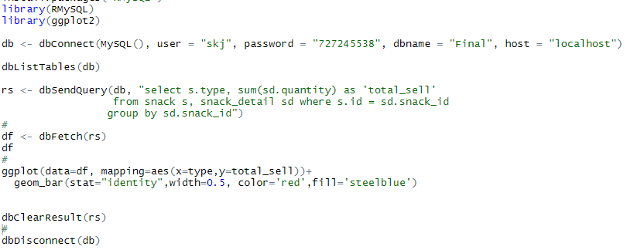

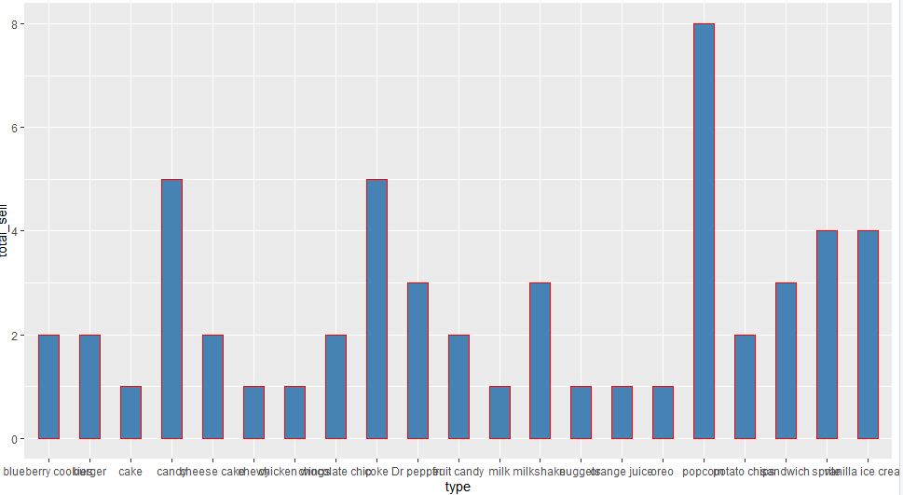
The graph shows that popcorn is the most popular snack

VII. Summary and recommendation
In this case study, we designed a database system that can be applied in a cinema to improve its efficiency and save the cost of human resources. This database can meet the basic requirements of selling, checking tickets, selling snacks, editing vip account, checking film information and managing storage. Specially, we designed the function to update the snack storage and vip credits. It is easy to reset if there is a misoperation.

